 | 
Performance Testing
Date July 7, 2026
Team ID 12344
Project Name Opticr | op
Maximum Marks | 5 Marks

Performance Testing Opticrop - Testing & Performance
Performance testing evaluates how your system behaves under expected and peak load conditions.
Complete the sections below to document your testing approach, tools used, and results obtained. Model Accuracy (validation set)
Random Forest Classifier : 100.00 %
Decision Tree Classifier : 98.18 %
Step 1: Testing Overview K-Nearest Neighbours : 97.50 %

Logistic Regression : 95.68 Field | % Details
Testing Tool Used Yield Regressor | [e.g., JMeter, Locust, k6, Postman]
Random Forest Regressor : R Type of Testing | 2 = 0.92+  [e.g., Load Testing, Stress Testing, Spike Testing]
Target Module / API Automated Unit Tests (pytest / u | nittest) [Specify which feature or endpoint was tested]
test_homepage_loads PASS Test Environment  test_predict_endpoint PASSED | D  [e.g., Local / Cloud / Hosted Server]
Test Date test_csv_logging PASSED  test_bounds_validation PASSED | D
=> 4 / 4 tests passed
Step 2: Test Scenarios
S.No | Test Scenario / Description | No. of Virtual Users | Duration (sec) | Expected Outcome
1
2
3
4

 | 
Step 3: Performance Test Results
S.No | Metric | Target Value | Actual Value | Status (Pass / Fail) | Remarks
1 | Response Time (Avg) | < 2 seconds
2 | Response Time (Max) | < 5 seconds
3 | Throughput (Req/sec)
4 | Error Rate | < 1%
5 | CPU Utilization | < 80%
6 | Memory Utilization | < 80%
Step 4: Observations & Analysis
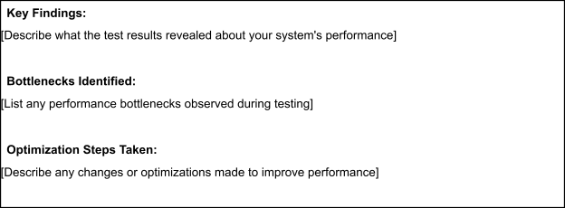
Step 5: Screenshots / Evidence
Attach screenshots of your performance testing tool results below (e.g., JMeter report, Locust graphs, k6
output):


